

Lab Assignment 1
Submitted By
ZEESHAN AHMED
SP22-BSE-019
Submitted To
Sir Muhammad Kamran
Subject
Mobile Application Development
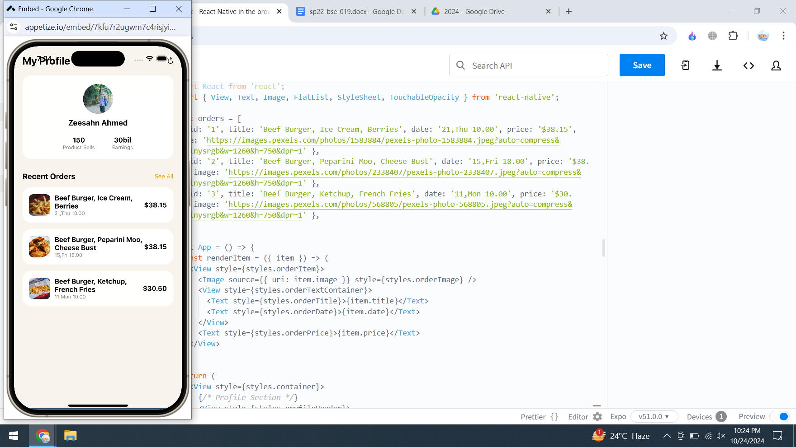
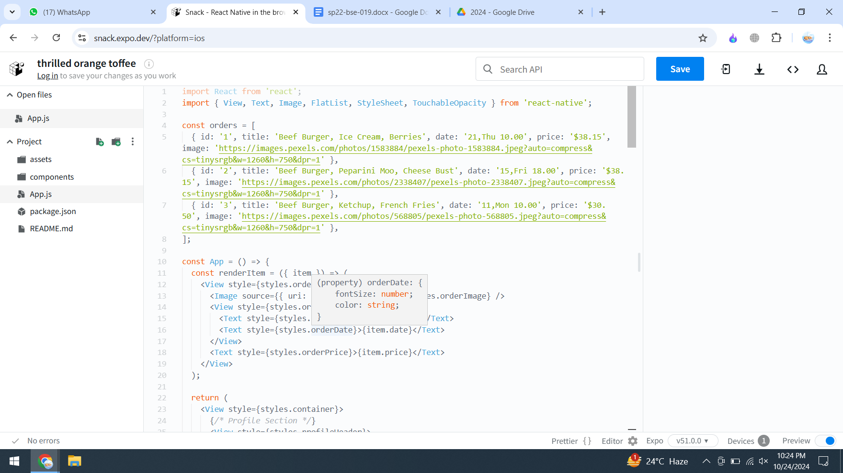
Code:
import React from 'react';
import { View, Text, Image, FlatList, StyleSheet, TouchableOpacity } from 'react-native';

const orders = [
{ id: '1', title: 'Beef Burger, Ice Cream, Berries', date: '21,Thu 10.00', price: '$38.15', image: 'https://images.pexels.com/photos/1583884/pexels-photo-1583884.jpeg?auto=compress&cs=tinysrgb&w=1260&h=750&dpr=1' },
{ id: '2', title: 'Beef Burger, Peparini Moo, Cheese Bust', date: '15,Fri 18.00', price: '$38.15', image: 'https://images.pexels.com/photos/2338407/pexels-photo-2338407.jpeg?auto=compress&cs=tinysrgb&w=1260&h=750&dpr=1' },
{ id: '3', title: 'Beef Burger, Ketchup, French Fries', date: '11,Mon 10.00', price: '$30.50', image: 'https://images.pexels.com/photos/568805/pexels-photo-568805.jpeg?auto=compress&cs=tinysrgb&w=1260&h=750&dpr=1' },
];

const App = () => {
const renderItem = ({ item }) => (
<View style={styles.orderItem}>
<Image source={{ uri: item.image }} style={styles.orderImage} />
<View style={styles.orderTextContainer}>
<Text style={styles.orderTitle}>{item.title}</Text>
<Text style={styles.orderDate}>{item.date}</Text>
</View>
<Text style={styles.orderPrice}>{item.price}</Text>
</View>
);

return (
<View style={styles.container}>
{/* Profile Section */}
<View style={styles.profileHeader}>
<Text style={styles.profileTitle}>My Profile</Text>
<TouchableOpacity>
{/* Icon or action button here */}
<Text style={styles.profileIcon}>↻</Text>
</TouchableOpacity>
</View>

<View style={styles.profileCard}>
<Image
source={{ uri: 'https://images.pexels.com/photos/1374509/pexels-photo-1374509.jpeg?auto=compress&cs=tinysrgb&w=1260&h=750&dpr=1' }}
style={styles.profileImage}
/>
<Text style={styles.profileName}>Zeesahn Ahmed</Text>
<View style={styles.profileStats}>
<View style={styles.statItem}>
<Text style={styles.statNumber}>150</Text>
<Text style={styles.statLabel}>Product Sells</Text>
</View>
<View style={styles.statItem}>
<Text style={styles.statNumber}>30bil</Text>
<Text style={styles.statLabel}>Earnings</Text>
</View>
</View>
</View>

{/* Recent Orders Section */}
<View style={styles.ordersHeader}>
<Text style={styles.ordersTitle}>Recent Orders</Text>
<TouchableOpacity>
<Text style={styles.seeAll}>See All</Text>
</TouchableOpacity>
</View>

<FlatList
data={orders}
renderItem={renderItem}
keyExtractor={(item) => item.id}
/>
</View>
);
};

const styles = StyleSheet.create({
container: {
flex: 1,
backgroundColor: '#F8F4EC',
padding: 20,
},
profileHeader: {
flexDirection: 'row',
justifyContent: 'space-between',
alignItems: 'center',
},
profileTitle: {
fontSize: 24,
fontWeight: 'bold',
},
profileIcon: {
fontSize: 18,
color: '#000',
},
profileCard: {
backgroundColor: '#FFF',
borderRadius: 20,
padding: 20,
marginTop: 20,
alignItems: 'center',
},
profileImage: {
width: 70,
height: 70,
borderRadius: 35,
},
profileName: {
marginTop: 10,
fontSize: 18,
fontWeight: 'bold',
},
profileStats: {
flexDirection: 'row',
marginTop: 20,
},
statItem: {
marginHorizontal: 20,
alignItems: 'center',
},
statNumber: {
fontSize: 16,
fontWeight: 'bold',
},
statLabel: {
fontSize: 12,
color: '#888',
},
ordersHeader: {
flexDirection: 'row',
justifyContent: 'space-between',
alignItems: 'center',
marginTop: 30,
},
ordersTitle: {
fontSize: 18,
fontWeight: 'bold',
},
seeAll: {
color: '#F0A500',
},
orderItem: {
flexDirection: 'row',
backgroundColor: '#FFF',
padding: 15,
marginTop: 15,
borderRadius: 20,
alignItems: 'center',
},
orderImage: {
width: 50,
height: 50,
borderRadius: 10,
},
orderTextContainer: {
flex: 1,
marginLeft: 10,
},
orderTitle: {
fontSize: 16,
fontWeight: 'bold',
},
orderDate: {
fontSize: 12,
color: '#888',
},
orderPrice: {
fontSize: 16,
fontWeight: 'bold',
},
});

export default App;

